**BETHLAHEM INSTITUTE OF ENGINEERING**

**(Afflication to AICTE & ANNA UNIVERSITY)**

**DEPARTMENTOFCOMPUTERSCIENCE& ENGINEERING**

# REPORT ON

**HX 8001 PROFESSIONALREADINESS FOR INNOVATION,**

**EMPLOYABILITY AND ENTREPENEURSHIP**

(Nalaiya thiran program)

PROJECT TITLE

**NATURAL DISASTER INTENSITY ANALYSIS AND CLASSIFICATION USING ARTIFICIAL INTELLIGENCE**

**TEAM**

# PNT2022TMID51308

Submitted by

SOFIYA G S( Team Lead)

ABISHIKA D

FEMI V

KARNAN D

## TABLE OF CONTENTS

|  |  |
| --- | --- |
| **CHAPTER**  **NO** | **TITLE** |
| 1. | **INTRODUCTION**  PROJECT OVERVIEW  PURPOSE |
| **2.** | **LITERATURE SURVEY**  EXISTING PROBLEM  REFERENCES  PROBLEM STATEMENT DEFINITION |
| **3.** | **IDEATION & PROPOSED SOLUTION**  EMPATHY MAP CANVAS  IDEATION & BRAINSTORMING  PROPOSED SOLUTION  PROBLEM SOLUTION FIT |
| **4.** | **REQUIREMENT ANALYSIS**  FUNCTIONAL REQUIREMENT  NON-FUNCTIONAL REQUIREMENTS |
| **5.** | **PROJECT DESIGN**  DATA FLOW DIAGRAMS  SOLUTION & TECHNICAL ARCHITECTURE USER STORIES |
| **6.** | **PROJECT PLANNING & SCHEDULING**  SPRINT PLANNING & ESTIMATION  SPRINT DELIVERY SCHEDULE  REPORTS FROM JIRA |

|  |  |
| --- | --- |
| **7.** | **CODING & SOLUTIONING**  FEATURE 1  FEATURE 2 |
| **8.** | **TESTING**  TEST CASES  ACCEPTANCE TESTING |
| **9.** | **RESULTS**  9.1 PERFORMANCE METRICS |
| **10.** | **ADVANTAGES & DISADVANTAGES** |
| **11.** | **CONCLUSION** |
| **12.** | **FUTURE SCOPE** |
| **13.** | **APPENDIX**  13.1 SOURCE CODE |

## CHAPTER 1 INTRODUCTION

### Project Overview

Natural disasters not only disturb the human ecological system but also destroy

the properties and critical infrastructures of human societies and even lead to permanent change in the ecosystem. Disaster can be caused by naturally occurring events such as earthquakes, cyclones, floods, and wildfires. To tackle this problem, we developed a multilayered deep convolutional neural network model that classifies the natural disaster and tells the intensity of disaster of natural The model uses an integrated webcam to capture the video frame and the video frame is compared with the Pre- trained model and the type of disaster is identified and showcased on the OpenCV window.

### Purpose

The purpose of this project to detect the natural disaster and reduce, or avoid,

the potential losses from hazards, assure prompt and appropriate assistance to victims of

disaster, and achieve rapid and effective recovery.

**CHAPTER 2**

## LITERATURE SURVEY

**TITLE** : A Deep Learning Approach of Recognizing Natural Disasters on Images.

### PROPOSED WORK

First, this work introduces to the research community a new dataset for the

joint classification of natural disaster types and intensity. Moreover, this study primarily aims to explore natural disasters recognition using a convolutional neural network and transfer learning. An open source tool is used for finding and removing the repeated images for analysis. Wildfire, Earthquake, Flood and Volcanic eruption are taken. In particular, this study attempts to build and train a lightweight convolutional neural network that can jointly recognize natural disaster types and intensity. Based on the intensity, it classifies as Severe, Moderate, Insignificant Lastly, this study attempts to measure the model performance using four performance measures; accuracy, precision, recall, and F1-Score.

### TOOLS USED/ALGORITHM

· Image Processing

· Slope NDVI

· Location API

· Cloud Architecture

· Google Earth Engine

· K-Means and Classification Algorithm

· RGB Scale

**TECHNOLOGY :** Artificial Intelligence

**TITLE :** Disaster Intensity-Based Selection of Training Samples for Remote Sensing Building Damage Classification.

### PROPOSED WORK

In this proposed work, two fully automatic procedures for the detection of

severely damaged buildings are introduced. The fundamental assumption is that samples that are located in areas with low disaster intensity mainly represent non-damaged buildings. Furthermore, areas with moderate to strong disaster intensities likely contain damaged and nondamaged buildings. Under this assumption, a procedure that is based on the automatic selection of training samples for learning and calibrating the standard support vector machine classifier is utilized. The second procedure is based on the use of two regularization parameters to define the support vectors. These frameworks avoid the collection of labeled building samples via field surveys and/or visual inspection of optical images, which requires a significant amount of time. The performance of the proposed method is evaluated via application to three real cases. The resulted accuracy ranges between 0.85 and 0.89, and thus, it shows that the result can be used for the rapid allocation of affected buildings.

### TOOLS USED/ALGORITHM

· Automatic labelling · Building damage

· Multi regularization parameters

· Demand Parameter

· Support Vector Machine (SVM)

**TECHNOLOGY :** Machine Learning

**TITLE :** Hurricane Damage Detection using Machine Learning and Deep Learning Techniques

### PROPOSED WORK

In this proposed work, Disaster detection can be done through social media and

satellites. Images obtained from satellites are widely used since capturing and processing of these images can be done in a shorter span of time. Satellite images help to recognize damage pattern caused by the disasters. The images from social media are also useful since they provide information on an immediate basis. Since manual methods are error- prone, deep learning and machine learning are used which used for detecting the damage caused by disasters effectively.

### TOOLS USED/ALGORITHM

· Social-media

· Satellite imagery

· Deep learning techniques

· CNN,VGG-16, ResNet

· Machine learning techniques · Support Vector

Machine, Decision trees, random forest.

**TECHNOLOGY :** Machine Learning, Deep Learning

### Existing Problem

Earlier we focus on post disaster relief and rehabilitation measures. Now the

focus is shifted. As per sec.2(e) of DM Act 2005, Disaster Management means a

coordination and integrated process of planning, organizing, coordinating, and implementing measures which are necessary or expedient for-

1. Prevention of danger or threat of any disaster

1. Preparedness to deal with any disaster
2. Prompt response to any threatening disaster situation or disaster

1. Assessing the severity or magnitude of effects of any disaster

1. Evacuation, rescue, and relief

1. Rehabilitation and reconstruction **References**

1. Mignan, A.; Broccardo, M. Neural network applications in earthquake prediction

(1994–2019): Meta-analytic and statistical insights on their limitations. Seism. Res. Lett. 2020,

91, 2330–2342. [CrossRef]

1. Tonini, M.; D’Andrea, M.; Biondi, G.; Degli Esposti, S.; Trucchia, A.;

Fiorucci, P. A Machine Learning-Based Approach for Wildfire Susceptibility

Mapping. The Case Study of the Liguria Region in Italy. Geosciences 2020, 10, 105. [CrossRef]

1. Islam, A.R.M.T.; Talukdar, S.; Mahato, S.; Kundu, S.; Eibek, K.U.;

Pham, Q.B.; Kuriqi, A.; Linh, N.T.T. Flood susceptibility modelling using advanced ensemble machine learning models. Geosci. Front. 2021, 12, 101075. [CrossRef]

1. Schlemper, J.; Caballero, J.; Hajnal, V.; Price, A.N.; Rueckert, D. A

deep cascade of convolutional neural networks for dynamic MR image reconstruction. IEEE Trans. Med. Imaging 2017, 37, 491–503. [CrossRef] [PubMed]

1. Tang, C.; Zhu, Q.; Wu, W.; Huang, W.; Hong, C.; Niu, X. PLANET: Improved convolutional neural networks with image enhancement for image

classification. Math. Probl. Eng. 2020, 2020. [CrossRef]

### Problem Statement Definition

People needs a way to classify and analyse the natural disaster so that they

can prevent themselves from losses due to the disaster and millions of lives.

People and animals are facing so many issues like loss of life, property,

resources and deterioration of the air quality due to the natural disaster. So we need to

analyse and detect natural disaster and protect them from such disaster.

## CHAPTER 3 IDEATION & PROPOSED SOLUTION

### Empathy Map Canvas

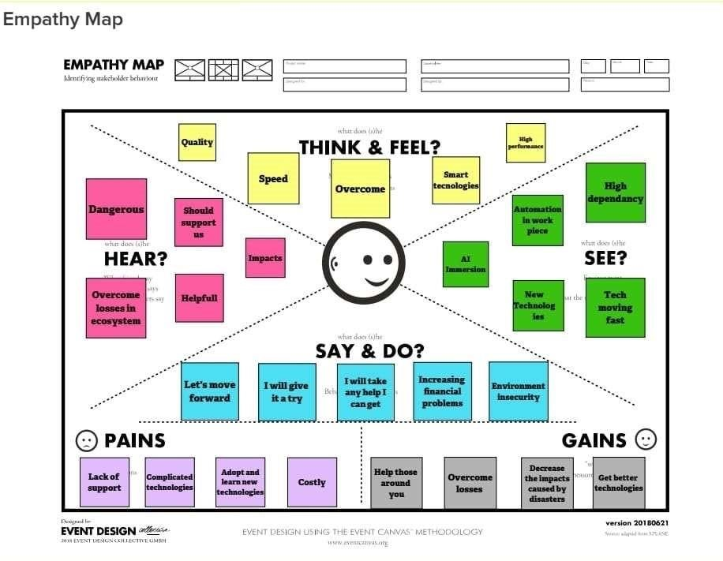

### Ideation & Brainstorming

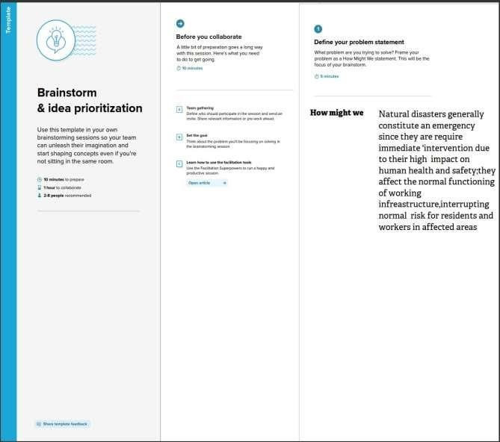

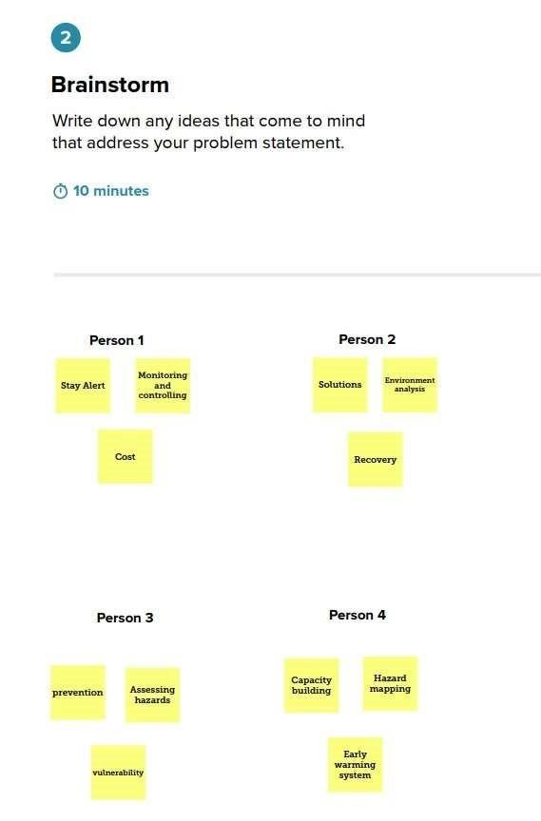

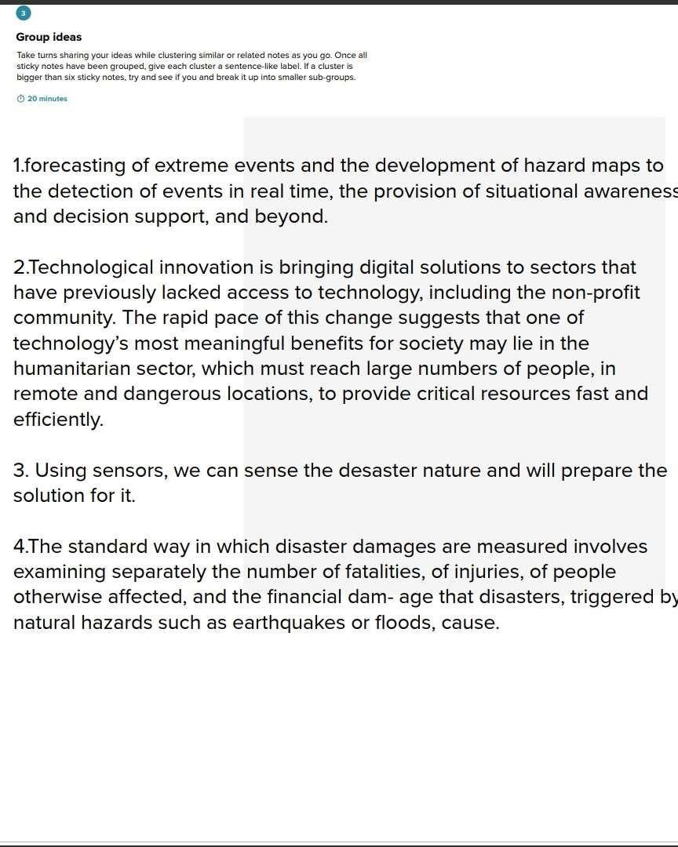

**Proposed solution**

|  |  |  |
| --- | --- | --- |
| **S.No.** | **Parameter** | **Description** |
| 1. | Problem Statement (Problem to be solved) | Natural disasters are inevitable, and the occurrence of disasters drastically affects the economy, ecosystem and human life. Natural disasters not only disturb the human ecological system but also destroy the properties and critical infrastructures of human societies and even lead to permanent change in the ecosystem. Disaster can be caused by naturally occurring events such as earthquakes, cyclones, floods, and wildfires. |
| 2. | Idea / Solution description | a multi layered deep convolution neural network model |
| 3. | Novelty / Uniqueness | This model that classifies the natural disaster and tells the intensity of disaster of natural. That uses an integrated web cam to capture the vedio frame and the vedio frame is compare with the Pretrained model and the type of disaster is identified and showcased on the open cv window |
| 4. | Social Impact / Customer Satisfaction | The peoples were depressed due to the disaster occure unpredictable time ,but the help of AI model they are happy with that they can avoidthe disaster and save their lives |
| 5. | Business Model (Revenue Model) | Government are the customer who are unable to predict the disaster.The disaster cause huge loses. |
| 6. | Scalability of the Solution | The proposed model achieved the highest accuracy as compared to other state-of-the-art methods due to its multilayered structure. The proposed model performs significantly better for natural disaster detection and classification, but in the future the model can be used for various natural disaster detection processes. |

### Problem Solution Fit

|  |
| --- |
|  |

## CHAPTER 4 REQUIREMENT ANALYSIS

### Functional Requirement

|  |  |  |
| --- | --- | --- |
| **FR**  **No.** | **Functional**  **Requirement(Epic)** | **Sub Requirement (Story / Sub-Task)** |
| **FR-1** | Request Permission | Access permission from web camera. |
| **FR-2** | Disaster Detection | Based on the webcam image, natural disaster is classified. |
| **FR-3** | Accuracy | Since the training and testing images are huge, The accuracy is higher. |
| **FR-4** | Speed | The generation of results from the input Images are faster. |
| **FR-5** | Resolution | The resolution of the integrated web camera should be high enough to capturethe video frames. |
| **FR-6** | User Interface | Maximizing the interaction in Web Designing Service. |

**Non-Functional Requirement**

|  |  |  |
| --- | --- | --- |
| **NFR. No.** | **Non-**  **Functional**  **Requirement** | **Description** |
| **NFR-1** | Usability | User friendly and classify the disaster easily. |
| **NFR-2** | Security | The model is secure due to the cloud deployment models and also there is no login issue. |
| **NFR-3** | Reliability | Accurate prediction of the natural disaster and the website can also be fault tolerant. |
| **NFR-4** | Performance | It is shown that the model gives almost 95  Percent accuracy after continuous training. |
| **NFR-5** | Availability | The website will be made available for 24 hours. |
| **NFR-6** | Scalability | The website can run on web browsers like Googlechrome, Microsoft edge and also it can be extended to the NDRFand customers. |

## CHAPTER 5 PROJECT DESIGN

### Data Flow Diagrams

A Data Flow Diagram (DFD) is a traditional visual representation of the information flows within a system. A neat and clear DFD can depict the right amount of the system requirement graphically. It shows how data to be enter and leaves the system, what changes the information, and where data is stored.

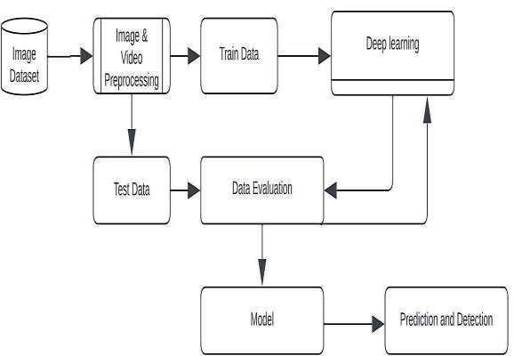

Flow Diagram

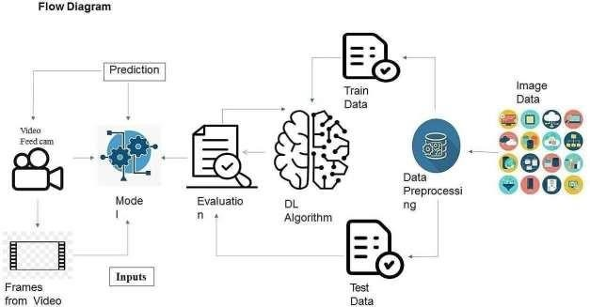

**Solution & Technical Architecture**

### Solution Architecture

Solution architecture is a complex process – with many sub-processes – that bridges the gap between business problems and technology solutions. Its goals are to:

* Find the best tech solution to solve existing business problems.

* Describe the structure, characteristics, behavior, and other aspects of the software to project stakeholders.
* Define features, development phases, and solution requirements.

* Provide specifications according to which the solution is defined, managed, and delivered.

### Solution Architecture Diagram



### Technical Architecture

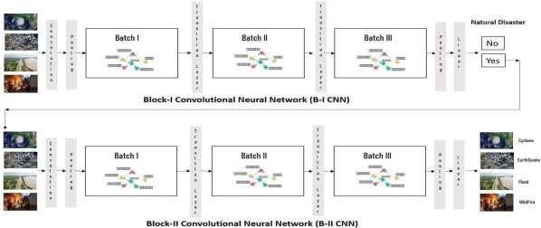

**Components &Technologies:**

|  |  |  |  |
| --- | --- | --- | --- |
| **S.No** | **Component** | **Description** | **Technology** |
| 1. | User Interface | User interacts with application for the detection of any Natural disaster’s intensity and classify which happened just before. | HTML, CSS,  JavaScript,  Django,  Python. |
| 3. | Disaster | This function is used to detect, | Decision |
|  | Detection | Outcomes from | trees, Regression, |
|  |  | the new trained data to perform new | Convolutio |
|  |  | tasks and solve new problems. | nal Neural networks. |
| 4. | Evaluation system | It monitors that how Algorithm performs on data as well as during training. | Chi-Square,  Confusion  Matrix, etc. |
| 5. | Input data | To interact with our model and give it problems to solve. Usually this takes the form of an API, auser interface, or a command- line interface. | Application programming interface, etc. |
| 6. | Data collection unit | Data is only useful if it’s accessible, so itneeds to be stored ideally in a consistent structure and conveniently inone place. | IBM Cloud, SQLServer. |
| 7. | Database management system | An organized collection of data stored in database, so that it can be easily accessedand managed. | MySQL,  DynamoDB etc. |

**Application Characteristics:**

|  |  |  |  |
| --- | --- | --- | --- |
| **S.No** | **Characteristics** | **Description** | **Technology** |
| 1. | Open-Source  Frameworks | An open source framework is a template for software development that is designed by a social network of software developers. These frameworks are free for public use and provide the foundation for building a software application. | Keras,  Tensorflow. |
| 2. | Authentication | This keep sour models secure and makes sure only those who havepermission can use them. | Encryption and  Decryption (OTP). |

|  |  |  |  |
| --- | --- | --- | --- |
| 3. | Application interface | User uses mobile application and web application to interact with model | Web  Develop ment  (HTML,C  SS) |
| 4. | Availability  (both  Online and  Offline work) | Its include both online and offline work. As good internet connection is need for online work to explore the software perfectly. Offline work includes the saved data to explore for later time. | Caching, backend server. |
| 5. | Regular  Updates | The truly excellent software product needs a continuous process of improvements and updates.  Maintain your server and make sure that your content is always up-to- date. Regularly update an app and enrich it with new features. | Waterfall  Approach,  Incremental  Approach,  Spiral Approach |
| 6. | Personalization | Software has features like flexible fonts, backgrounds, settings, colour themes, etc. which make a software interface looks good and functional. | ● CSS |

### User Stories

|  |  |  |  |
| --- | --- | --- | --- |
| **Functional**  **Requirement**  **(Epic)** | **User**  **Story**  **Number** | **User Story / Task** | **Acceptance criteria** |
| Collection of dataset | USN-1 | As a user, I can collect the dataset for monitoring and analyzing. | Enough data collected for training Model. |
| Home Page | USN-2 | As a user, I want to know to about the basics of frequently occurring Disasters. | I can get the idea about the Application. |
| Intro page | USN-3 | As a user, I want to about the introduction of Disaster in particular areas. | I can get idea about the  disaster and where it occurs. |
| Open webcam | USN-4 | As a user, I adapt with the webcam to analyze and classify the Disaster from video capturing | I can capture a video o image of particular disaste to analyze and classify. |
| Analysis of required phenomenon | USN-5 | As a user, I can regulate certain factors influencing the action and report on past event analysis. | Model should be easy to use & working fine from the web app. |

|  |  |  |  |
| --- | --- | --- | --- |
| Algorithm selection | USN-6 | As a user, I can choose the required algorithm for specific analysis. | Selection must give the better accuracy and better output. |

r

|  |  |  |  |
| --- | --- | --- | --- |
| Training and  Testing | USN-7 | As a user, I can train and test the model using the algorithm. | Training the model to classify and analyze the  intensity |
| Detection and analysis of data | USN-8 | As a user, I can detect and visualize the data effectively. | I can capture a video or image of particular disaster to analyze and detect. |
| Model building | USN-9 | As a user I can build with the web application. | Model should be predicting occurrence of the disaste and intensity level o disaster. |
| Integrate the web app with the AI  Model | USN-10 | As a user, I can use Flask app to use model easily through web app. | Model should be easy to use and working fine from the web app. |
| Model deployment | USN-11 | As an administrator, I can deploy the AI model in IBM Cloud. | Model’s prediction should be available for users to make decision. |

r f

**CHAPTER 6**

**CHAPTER 6**  **PROJECT PLANNING & SCHEDULING**

## Sprint planning & Estimation

|  |  |  |  |  |
| --- | --- | --- | --- | --- |
| **Sprint** | **Functional**  **Requirement**  **(Epic)** | **User**  **Story**  **Number** | **User Story / Task** | **Story Points** |
| Sprint-1 | Collection of  Dataset | USN-1 | As a user, I can collect the dataset for monitoring and analysing. | 5 |
| Sprint-1 | Home page | USN-2 | As a user, I want to know to about the basics of frequently occurring Disasters. | 5 |
| Sprint-1 | Intro page | USN-3 | As a user, I want to about the introduction of Disaster in particular areas. | 5 |
| Sprint-1 | Open webcam | USN-4 | As a user, I adapt with the webcam to analyse and classify the Disaster from video capturing. | 5 |
| Sprint-2 | Analysis of required phenomenon | USN-5 | As a user, I can regulate certain factors influencing the action and report on past event analysis. | 5 |
| Sprint-2 | Algorithm selection | USN-6 | As a user, I can choose the required Algorithm for specific analysis. | 5 |
| Sprint-2 | Training and  Testing | USN-7 | As a user, I can train and test the model using the algorithm. | 10 |
| Sprint-3 | Detection and analysis of data | USN-8 | As a user, I can detect and visualise the data effectively. | 10 |
| Sprint-3 | Model building | USN-9 | As a user, I can build with the web application. | 10 |
| Sprint-4 | Integrate the web app with the AI model | USN-11 | As a user, I can use Flask app to use model easily through web app. | 10 |
| Sprint-4 | Model deployment | USN-12 | As an administrator, I can deploy the AI model in IBM Cloud. | 10 |

### Sprint Delivery schedule

|  |  |  |  |  |  |
| --- | --- | --- | --- | --- | --- |
| **Sprint** | **Total**  **Story**  **Points** | **Duration** | **Sprint Start Date** | **Story Points**  **Completed (as on Planned**  **End Date)** | **Sprint Release Date (Actual)** |
| Sprint-1 | 20 | 6 Days | 24 Oct 2022 | 20 | 29 Oct 2022 |
| Sprint-2 | 20 | 6 Days | 31 Oct 2022 | 20 | 05 Nov 2022 |
| Sprint-3 | 20 | 6 Days | 07 Nov 2022 | 20 | 12 Nov 2022 |
| Sprint-4 | 20 | 6 Days | 14 Nov 2022 | 20 | 19 Nov 2022 |

**Reports from Jira Velocity:**

Imagine we have a 10-day sprint duration, and the velocity of the team is 20

(points per sprint). Let’s calculate the team’s average velocity (AV) per iteration unit

(story points per day)

### Average velocity = Sprint duration / velocity

**=20/6**

**=3**

**Burndown Chart:**

A burn down chart is a graphical representation of work left to do versus time. It is often used in agile [software development meth](https://www.visual-paradigm.com/scrum/what-is-agile-software-development/)odologies such as [Scrum.](https://www.visual-paradigm.com/scrum/scrum-in-3-minutes/) However, burn down charts can be applied to any project containing measurable progress over time.

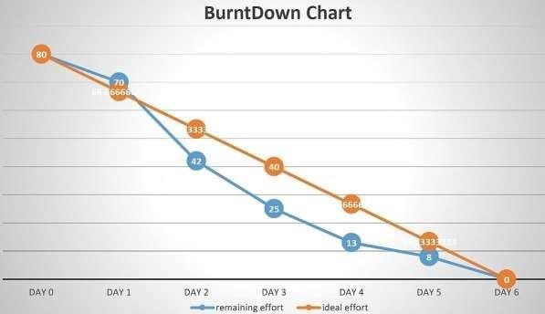

## CHAPTER 7

**CODING & SOLUTIONING**

### Feature 1

The project focuses on the analysis of intensity of Disaster for giving precautionary measures for the people living in the Danger zone.

It focuses on classifying the type of Disaster which oftenly occurs in that particular zone.

### Feature 2

The accuracy of the project is improved more better than the previously submitted models.

The accuracy is improved by training and testing more images in the dataset.

## CHAPTER 8 TESTING

### Test cases

|  |  |  |  |  |  |
| --- | --- | --- | --- | --- | --- |
| **Test Case ID** | **Component** | **Test Scenario** | **Expected Result** | **Actual**  **Result** | **Status** |
| TC_001 | Home Page | Verify user is able to see the Home page | Home page should Display | Working as expected | Pass |
| TC_002 | Home Page | Verify the UI elements in  Home page | Application  should show  below UI elements:  Home page button  Intro page button  Open webcam button | Working as expected | Pass |
| TC_003 | Home Page | Verify user is able to see the cards about  Disaster | Application should show the cards about Disaster. | Working as expected | Pass |
| TC_004 | Home Page | Verify user is able to navigate to the required page | Application should  navigate to the  Intro page | Working as expected | Pass |
| TC_005 | Intro Page | Verify user is able to see the Intro page | Intro page should display | Working as expected | Pass |
| TC_006 | Intro Page | Verify the UI  Elements in  Intropage | Application  should show below UI  elements: Home  page  Intro page  Open webcam button | Working as expected | Pass |

|  |  |  |  |  |  |
| --- | --- | --- | --- | --- | --- |
| TC_007 | Intro Page | Verify the user is able to see the introduction of  the Disaster | Application should show the sentences about the Disaster | Working as expected | Pass |
| TC_008 | Intro Page | Verify user is able to navigate  to the required page | Application should navigate to the  Open webcam page | Working as expected | Pass |
| TC_009 | Webcam  page | Verify user is able to see the webcam page | Webcam page is displayed | Working as expected | Pass |
| TC_010 | Webcam  page | Verify the  Emergency pull button is visible while the webcam is not connected | Application  should show below UI elements:  a. Emergency pull button | Working as expected | Pass |
| TC_011 | Webcam  page | Verify user is able to see the output window | Application should detect the type of  Disaster from the real time video | Working as expected | Pass |

### User Acceptance Testing

It is to briefly explain the test coverage and open issues of the natural disasters intensity analysis and classification using artificial intelligence project at the time of the release to User Acceptance Testing (UAT). **Defect Analysis:**

This report shows the number of resolved or closed bugs at each severity level, and how they were resolved

|  |  |  |  |  |  |
| --- | --- | --- | --- | --- | --- |
| **Resolution** | **Severity 1** | **Severity 2** | **Severity 3** | **Severity 4** | **Subtotal** |
| By Design | 1 | 0 | 0 | 2 | 3 |
| Duplicate | 1 | 0 | 0 | 0 | 1 |
| External | 0 | 0 | 0 | 0 | 0 |
| Fixed | 1 | 0 | 0 | 2 | 3 |
| Not  Reproduce | 0 | 0 | 0 | 0 | 0 |
| Skipped | 0 | 0 | 0 | 1 | 1 |
| Won't Fix | 0 | 0 | 0 | 0 | 0 |
| Totals | 3 | 0 | 0 | 5 | 8 |

**Test Case Analysis:**

This report shows the number of test cases that have passed, failed, and

untested.

|  |  |  |  |  |
| --- | --- | --- | --- | --- |
| **Section** | **Test Cases** | **Not Tested** | **Fail** | **Pass** |
| Home Page | 4 | 0 | 0 | 4 |
| Intro Page | 4 | 0 | 0 | 4 |
| Open Webcam | 3 | 0 | 0 | 3 |

## CHAPTER 9 RESULTS

### Performance Metrics

The nature disaster intensity analysis and classification with test data and train data has been executed successfully. The model has been trained over 1000+ images and the model have an accuracy of nearly 99% and the model has been tested withthe data which is separate from the trained data and has predicted the data well.

### Output of application

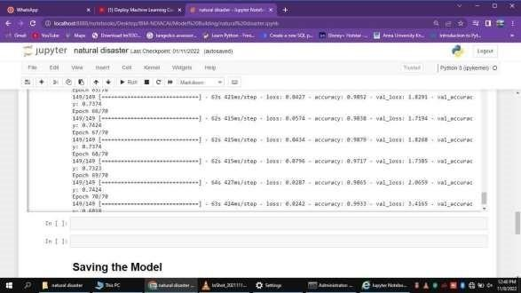

## HOME PAGE

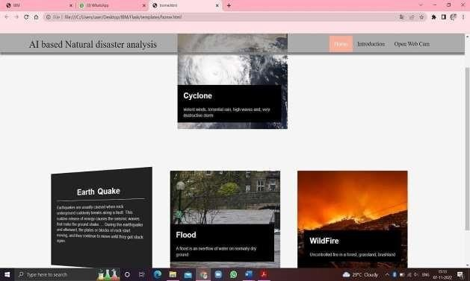

### INTRODUCTION PAGE

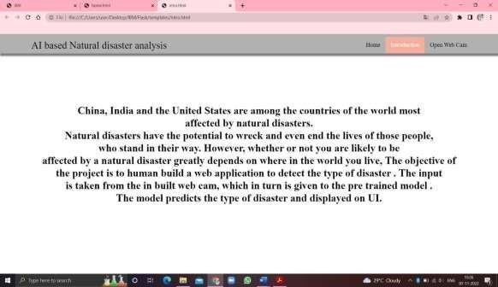

### WEB CAM

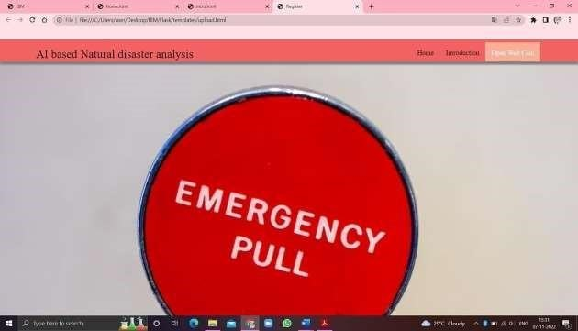

### DETECTION OF NATURE DISASTER

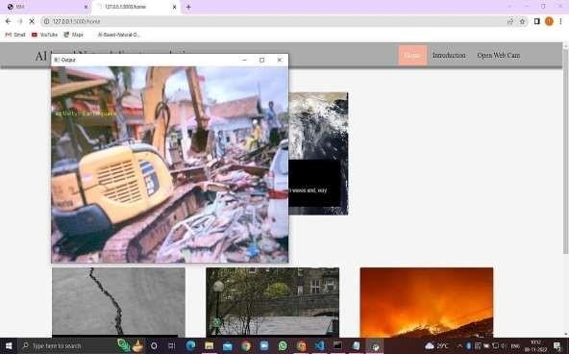

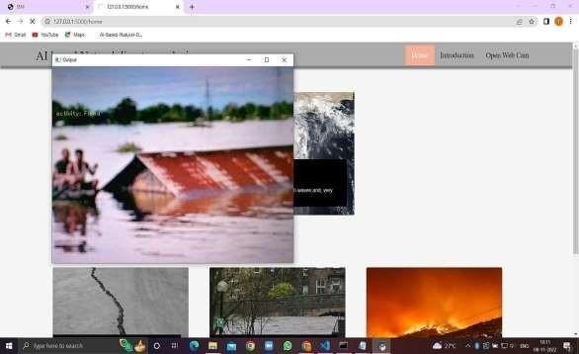

## ADVANTAGES & DISADVANTAGES

### ADVANTAGES

1. The proposed model will be used as a real time natural disaster detection model and provide some upcoming predictions for future disasters.
2. The model is to detect and classify the type of disaster and The model have a high accuracy rate ( 99.33).
3. The model was used to prevent natural disasters in the future and model can be used to predict future disasters and take some action against heavy loss of human ecological systems and property.
4. The proposed system helps to reduce the impact of hazards occur during natural disaster. This provides an efficient way to warn and educate people about disaster prone areas.
5. It will help us be prepared in times of disaster

### DISADVANTAGES

1. The resultant model unable to validate the model performance under uncontrolled conditions.
2. The model cannot be used for various natural disaster

## CONCLUSION

It focused how image from given dataset (trained dataset) in field and past data set used predict the pattern of different nature disaster using CNN model. In the system had applied different type of CNN compared the accuracy. The natural disaster in Indonesia frequently happened, due to the geographical position of the country. Thus, natural disasters mostly occurred as an impact of the natural condition. However, the weather and climate condition has also influenced and triggered the disasters.

## FUTURE SCOPE

In the future, the research will be continued to obtain the data from all over the country, not only west java province, and with the use of more complete analysis, so that the government or related institution could make a better anticipation work as a mitigation effort.

## APPENDIX

**Inserting necessary libraries**

import numpy as np **#used for numerical analysis** import tensorflow **#open**

**source used for both ML and DL for computation**

from tensorflow.keras.models import Sequential **#it is a plain stack of layers**

from tensorflow.keras import layers **#A layer consists of a tensor-in tensor-out computation function**

### #Dense layer is the regular deeply connected neural network layer

from tensorflow.keras.layers import Dense,Flatten

#Faltten-used fot flattening the input or change the dimension

### from tensorflow.keras.layers import Conv2D,MaxPooling2D #Convolutional layer #MaxPooling2D-for downsampling the image

from keras.preprocessing.image import ImageDataGenerator

tensorflow. version

tensorflow.keras. version

**Image Data Augumentation**

## CHAPTER 14

**#setting parameter for Image Data agumentation to the training data**

train_datagen =

ImageDataGenerator(rescale=1./255,shear_range=0.2,zoom_range=0.2,horizontal_ flip=True)

**#Image Data agumentation to the testing data**

test_datagen=ImageDataGenerator(rescale=1./255)

**Loading our data and performing Data Augumentation**

### #performing data agumentation to train data

x_train=train_datagen.flow_from_directory(r'C:\Users\vasanth\Desktop\IBM Project\dataset\train_set',target_size=(64, 64),batch_size=5,

color_mode='rgb',class_mode='categorical')

### #performing data agumentation to test data

x_test=test_datagen.flow_from_directory(r'C:\Users\vasanth\Desktop\IBM Project\dataset\test_set',target_size=(64, 64),batch_size=5,

color_mode='rgb',class_mode='categorical')

### print(x_train.class_indices)#checking the number of classes print(x_test.class_indices)#checking the number of classes

from collections import Counter as c

c(x_train .labels)

**Creating the Model**

**# Initializing the CNN**

classifier = Sequential()

### # First convolution layer and poolingo

classifier.add(Conv2D(32, (3, 3), input_shape=(64, 64, 3), activation='relu'))

classifier.add(MaxPooling2D(pool_size=(2, 2)))

classifier.add(Conv2D(32, (3, 3), input_shape=(64, 64, 3), activation='relu'))

**# Second convolution layer and pooling**

classifier.add(Conv2D(32, (3, 3), activation='relu'))

### # input_shape is going to be the pooled feature maps from the previous convolution layer

classifier.add(MaxPooling2D(pool_size=(2, 2)))

classifier.add(Conv2D(32, (3, 3), input_shape=(64, 64, 3), activation='relu'))

### # Flattening the layers

classifier.add(Flatten())

**# Adding a fully connected layer** classifier.add(Dense(units=128,

activation='relu'))

classifier.add(Dense(units=4, activation='softmax')) **# softmax for more than 2**

classifier.summary() #**summary of our model**

**# Compiling the Model**

**# Compiling the CNN**

### # categorical_crossentropy for more than 2

classifier.compile(optimizer='adam', loss='categorical_crossentropy',

metrics=['accuracy'])

**# Fitting the Model** classifier.fit_generator( generator=x_train,steps_per_epoch

= len(x_train), epochs=10, validation_data=x_test,validation_steps = len(x_test**))# No of**  **images in test set # Saving the Model** classifier.save('disaster.h5') model_json = classifier.to_json() with

open("model-

bw.json", "w") as json_file: json_file.write(model_json)

### # Predicting Results

from tensorflow.keras.models import load_model from keras.preprocessing import image model = load_model("disaster.h5") **#loading the model for testing**

img=image.load_img(r"C:\Users\vasanth\Desktop\IBMProject\dataset\test_set\Cyc

lone\921.jpg",grayscale=False,target_size= (64,64)) **#loading of the image\n**

x = image.img_to_array(img**)#image to array\n",**

x = np.expand_dims(x,axis = 0)**#changing the shape\n",**  pred = model.predict_classes(x**)#predicting the classes\n",**

pred index=['Cyclone','Earthquake','Flood','Wildfire'] result=str(index[pred[0]]) result

**Links to find files, documents and result related to this project,**

**GitHub: https://github.com/IBM-EPBL/IBM-Project-13984-1659538208**

**Project Demo Link:**

**https://drive.google.com/file/d/1Q7o9Q39c6qqdfAmOakM303TX1my2**

### E79f/view